|  |
| --- |
|  |
| **Web and Mobile**  **Application Development** |
| |  |  |  | | --- | --- | --- | | Rajeshwari Reddy GUMMADI |  | CN5006 | |

**Portfolio**

Reflection of Lab Exercise

First week of lab exercise I did some programming using visual studio code and the language I used was java script.

* I downloaded visual studio code and installed it to do the programming.
* I opened the visual studio code for programming
* I also opened the terminal window where I can see the display when I run the program.
* Then I opened the new file called labweek1.
* Then I started to code to display the string “This is my first practical class” and “My first programe” in the Terminal window.
* Then by writing node labweek1 beside the location where I save my file and then press enter, it displayed the string.

**Addition**

Below is the screen shot of my code where I calculated two numbers by adding. I defined variables as const num1 = 10 and const num2 = 20 here const stands for fixed number which cannot be changed. Then the string along with the total was displayed as “The sum of 10 and 20 is: 30 ” in Terminal window.

**Week 1 Lab**

**Subtraction**

Below is the screen shot of my code where I calculated two numbers by subtracting. I defined variables as const num3 = 30 and const num4 = 15. Then the string along with the total was displayed as “The difference between 30 and 15 is: 15 ” in Terminal window.

**Multiplication**

Below is the screen shot of my code where I calculated two numbers by multiplying. I defined variables as const num5 = 25 and const num6 = 5. Then the string along with the total was displayed as “The multiplication of 25 and 5 is: 125 ” in Terminal window.

**Division**

Below is the screen shot of my code where I calculated two numbers by division. I defined variables as const num7 = 50 and const num8 = 10. Then the string along with the total was displayed as “The division of 50 and 10 is: 5 ” in Terminal window.

This is the screenshot of where I used the if , else if, and else statements.

* In this program I want to check if the number is positive, negative, or zero.
* For this I have to take input from the user to enter the number.
* If the number is greater than zero, then it should display “The number is positive”.
* If the number is equal to zero, display should be “The number is zero”.
* If the number is less than zero, it should display “ The number is negative”

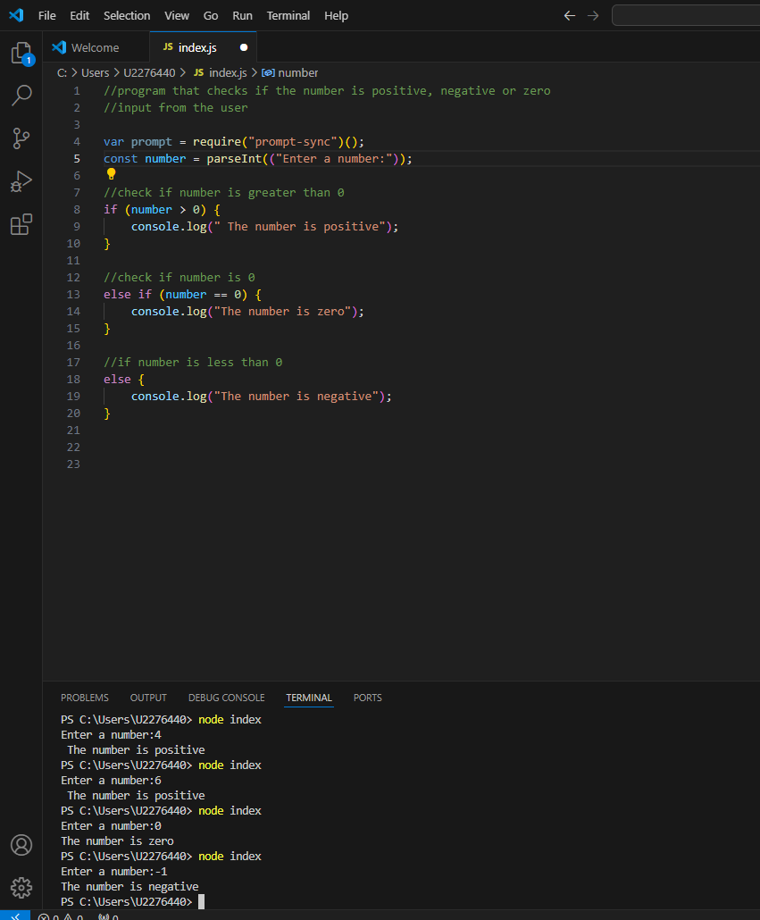

The terminal window displays the output what was required.